
A 10
SET NO : 2

Sreenidhi Institute of Science & Technology
(An Autonomous Institution)
Code No: 101CS01/111CS01

B. TECH. I – Year II – Semester Examinations, June/July, 2012 (Regular/Suppli)
DATA STRUCTURES AND C++ (Common to ME, CSE, IT & BT)

Time: 3 Hours Max. Marks : 70

Note : No additional answer sheets will be provided.

Part-A (Objective Type)
Max.Marks:20

Answer all QUESTIONS.

1. What is a selection sorting technique.

2. Give the maximum number of nodes in a binary tree of height h.

3. Indicate whether the following statements are true / false
a) Items with in a class defaults to public if the key words public and private are not included with in the class definition.
b) Constructor can have any name that you desire.
c) There can be only one constructor within a class definition.
d) There can be only one destructor within a class definition.

4. Is it possible using operator overloading to change the behavior of "+" operator on integers? Justify your answer.

5. Assume that "t" is an object of class test, which has member functions a(), b(), c() and d(). If the functions a(), b() and c() all return references to an object of class test (using the dereference this pointer) and function d() returns void, which of the following will not produce a syntax error.
a) t.a().b().d() b) a().b().t c) t.d()c() d) t.a().t.d()

6. What is the difference between an abstract data type (ADT) and a data structures.

7. If the value of A,B,C, and D are 2,3,4 and 5 respectively, what is the value of following post fix expression.
ABC + * D -

8. Write a recursive function to reverse elements of a queue using the operations of a queue.

9. What is the advantage of using a dummy header in a circular linked list?

10. Which linear data structure is used to breadth first traversal of a graph.

Part – B
Max. Marks: 50

ANSWER ANY FIVE QUESTIONS. EACH QUESTION CARRIES 10 MARKS.

1. Consider an array containing the elements 4,3,5,6,2,1, show the current state of an array after each iteration of the following algorithms. (sort the array in ascending order)
a) selections sort b) insertion sort

2. Write a C++ program to implement a complex number class with the following operations.
a) Addition b) Subtraction c) multiplication d) display

3. a) What are static class members? How do you initialize them? Illustrate with examples.

b) Explain different ways of writing constructors of derived classes.

4. Write short note on
a) virtual function b) minimal spanning trees c) merge sort

5. Write a C program to implement circular queue operations.

6. Write a C program to implement following operations on a linked list.
a) Reverse the list in place.
b) Find n^{th} element from last position.

7. a) Construct a Binary tree from the following in-order and pre-order traversal.
In-order: D B H E A I F J C G
pre-order: A B C D E H F I J G

b) Write a recursive function to insert an element into a binary search tree.

8. Given the graph below, draw its
a) adjacent matrix representation.
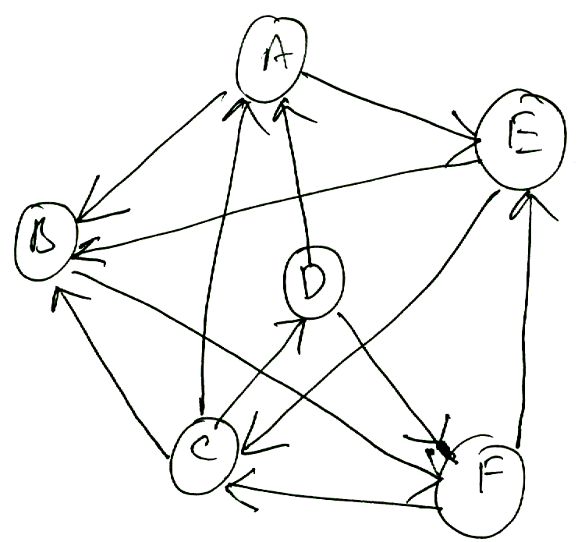

b) Demonstrate how depth first search can be used to check whether there is a path ` from A to D.

-- 00 -- 00 --

